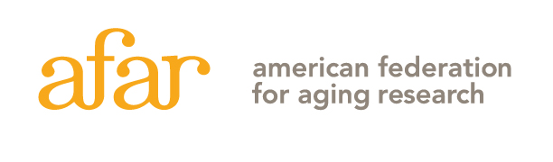
55 West 39th Street, 16th Floor, New York, NY 10018 (212) 703-9977

2026 McKnight Brain Research Foundation Innovator Awards in
Cognitive Aging and Memory Loss
Letter of Intent Instruction Sheet - Do not include with your Letter of Intent!

Please read the program guidelines carefully on the AFAR website before completing this LOI. Frequently asked questions can be found here, and things to consider when applying can be found here.

INSTRUCTIONS: The Letter of Intent must be submitted here no later than April 15, 2026, at 5:00 p.m., EST, as a single PDF file application, not to exceed 5 MB. No late submissions will be accepted. The application file should be named as follows: last name, first name; for example, “Lee, Robin.pdf”.

Letter of Intent
Letters of intent will be evaluated on the relevance and significance of the proposed research to the mechanisms of aging and qualifications of the applicant as outlined in the McKnight Brain Research Foundation Innovator Awards in Cognitive Aging and Memory Loss Guidelines.

Submit the LOI in the order as described below. Insert page number and applicant's name at the top of each page, use a font that is not smaller than 11 pt. with at least 1/2 inch margins on all sides for the proposal. Any figures and essential references must be included on page 2.

A complete Letter of Intent (no more than 7 pages total) includes:
Page 1: Title Page with abstract (include in space provided, see below)
Page 2: Project Description, A-D must be addressed, following the format below:
- Significance of this research to the field of cognitive aging and memory loss
- Brief description of hypothesis
- List of Specific Aims
- Any figures and essential references (optional)
Pages 3-7: NIH-style biosketch, 2021 version (recently expired) (download template here.) Up to 5 pages total. Be sure to include past and current funding with dollar amounts, Other Support Pages are allowed in addition to the 5 pages as needed.

Your Dean or CEO must complete an institutional commitment form providing evidence of institutional commitment, to be submitted separately by the April 15 deadline to afarapplication@afar.org. Download the form here: MBRF AFAR Institutional Commitment Form

The Letters of Intent will be reviewed by a committee. Applicants will be notified by mid-June, a subset of applicants will be invited to submit a full application by mid-August.

THIS IS THE INSTRUCTION SHEET! DO NOT INCLUDE IT WITH YOUR LETTER OF INTENT. PLEASE FOLLOW THE INSTRUCTIONS CAREFULLY. LOIs THAT DO NOT FOLLOW THE REQUIRED FORMAT (FOR EXAMPLE, EXCEEDING PAGE LIMIT, MATERIALS IN WRONG ORDER) WILL BE ADMINISTRATIVELY ELIMINATED. Contact grants@afar.org should you have any questions.
2026 McKnight Brain Research Foundation Innovator Awards in Cognitive Aging and Memory Loss

Letter of Intent
[Title Page: should be the first page of your application]

ONLY ONE LETTER OF INTENT PER INDIVIDUAL MAY BE SUBMITTED EACH YEAR.
Applicant Information  First Name: Last Name:  Degree(s):  Academic Title:  Institution:  Department:  Mailing Address:  City: State:  Zip Code:  Phone: E-mail: | Project Title:  Model System(s):
Are you an Assistant Professor? Yes No
If No, are you an Associate Professor? Yes No If Yes, indicate date of appointment:
Do you have an R01 or equivalent funding? Yes No

ABSTRACT: Provide a summary of your research proposal. Do not exceed space provided.
Keywords:

