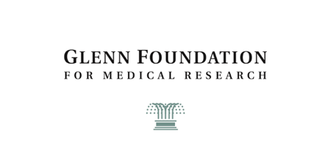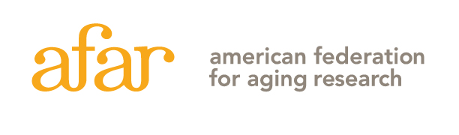

The Paul F. Glenn/AFAR Conference on the Biology of Aging
The 39th Annual AFAR Grantee Conference

May 27 – 29, 2026

Ritz-Carlton Bacara
Santa Barbara, CA

DRAFT 2/23/2025

Grantees will be invited to present their research in a virtual datablitz session which will take place the week prior to the Grantee Conference. Details will be sent at a later date.

Wednesday, May 27, 2026

3:30 - 4:00 pm Registration/reception

4:00 – 4:10 pm Welcome

4:10 – 4:30 pm “Stem Cell Aging: Evolutionary Trade-Offs and Survivorship Bias”
Thomas Rando, MD, PhD
Director, UCLA Borad Stem Cell Research Center
Professor, Neurology
AFAR Board President

4:30 – 4:50 pm 2022 Glenn Breakthroughs in Gerontology (BIG) Presentation

Edward Chouchani, PhD,
Professor of Cell Biology
Dana-Farber Cancer Institute
Harvard Medical School
Investigator, Howard Hughes Medical Institute

4:50 – 5:20 pm Break

Wednesday, May 27, 2026 (continued)

5:20 – 6:00 pm 2023 McKnight Innovator Awards in Cognitive Aging and Memory Loss Presentations

Denise Cai, PhD
Associate Professor,
Co-Director, Computational and Systems Neuroscience Center
Icahn School of Medicine at Mount Sinai

Christoph Thaiss, PhD
Assistant Professor, Stanford University

6:00 – 8:00 pm Dinner

Thursday, May 28, 2026

7:30 – 9:00 am Breakfast

9:00 – 9:20 am Celebration of AFAR’s 45th anniversary with a look back at the collaboration between GFMR and AFAR

9:20 – 9:40 am Andrew Brack, PhD
Program Manager, Proactive Health, ARPA-H

9:40 – 10:00 am Daniel Jarosz, PhD
Associate Professor
Chemical & Systems Biology // Developmental Biology
Senior Associate Dean for Basic Science
Stanford University School of Medicine

10:00 – 10:30 am Break

10:30 – 10:50 am Corina Amor, MD, PhD
Assistant Professor
Co-Chair Dept. Cellular Communication
Cold Spring Harbor Laboratory
Freeman Hrabowski Scholar
Howard Hughes Medical Institute

10:50 – 11:20 am Poster presenter 1 minute poster pitch – group 1

11:30 am – 1:00 pm Lunch

1:00 – 1:30 pm Poster presenter 1 minute poster pitch – group 2

Thursday, May 28, 2026 (continued)

1:30 – 1:50 pm Leanne Jones, PhD
Professor, Anatomy
Director, Bakar Aging Research Institute
University of California, San Francisco

1:50 – 4:00 pm Poster session

4:00 – 6:00 pm Free time

6:00 – 7:00 pm Reception

7:00 – 7:30 pm Dinner Speaker

Peter Hotez, MD, PhD
Dean of the National School of Tropical Medicine and Professor of Pediatrics and Molecular Virology & Microbiology at Baylor College of Medicine

7:30 - 9:00 pm Dinner

Friday, May 29, 2026

7:00 – 9:00 am Breakfast

9:00 am Conference adjourns

