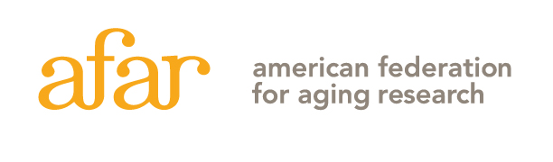
55 West 39th Street, 16th Floor, New York, NY 10018 (212) 703-9977

2026 Glenn Foundation Discovery Award
Letter of Intent Instruction Sheet
Do not include with your Letter of Intent!

Please carefully read the application guidelines on the AFAR website before completing this LOI. Frequently asked questions can be found here, and things to consider when applying can be found here.

INSTRUCTIONS: The Letter of Intent must be submitted here no later than February 18, 2026, at 5:00 p.m., EST, as a single PDF file application, not to exceed 5 MB. No late submissions will be accepted. The application file should be named as follows: last name, first name; for example, “Lee, Pat.pdf”.

Letter of Intent
Letters of intent will be evaluated on the relevance and significance of the proposed research to the mechanisms of aging and qualifications of the applicant as outlined in the Discovery Award guidelines.

Please submit the LOI in the order listed on this page. Insert page number and applicant's name at the top of each page and use a font that is not smaller than 11 pt. with at least ½ inch margins on all sides. Any figures and essential references must be included on page 2.

The Letter of Intent (up to 7 pages total) must consist of the following:
Page 1: Title Page, with abstract (in space provided); include in abstract a description of your model system and approach
Page 2: Project Description, which must be addressed in the order below.
- Lead statement why this project has the potential to yield new discoveries in biology applicable to human aging and healthspan, and/or establish new approaches for clinically relevant strategies, treatments or therapeutics that address human aging and healthspan.
- Significance and relevance of this research to the field of aging
- Brief description of hypothesis or hypotheses
- Specific Aims
- Any figures and essential references (optional)
Page 3-7: NIH-style biosketch “old version” for the applicant (up to 5 pages total), include funding pages – applicants must be full-time faculty members at the rank of Assistant Professor or higher; applicants who are at the rank of Assistant Professor must hold an R01 or equivalent funding.

The Letters of Intent will be reviewed by a committee. Applicants will be notified by early May, and a subset of applicants will be invited to submit a full application for a mid-June deadline.
THIS IS THE INSTRUCTION SHEET, DO NOT INCLUDE IT WITH YOUR LETTER OF INTENT. PLEASE FOLLOW THE INSTRUCTIONS CAREFULLY. LOIs THAT DO NOT FOLLOW THE REQUIRED FORMAT (FOR EXAMPLE, EXCEEDING PAGE LIMIT) WILL BE ADMINISTRATIVELY ELIMINATED. Please contact grants@afar.org with any questions.
2026 Glenn Foundation Discovery Award
Letter of Intent
[Title page: should be the first page of your LOI]

ONLY ONE LETTER OF INTENT PER INDIVIDUAL MAY BE SUBMITTED EACH YEAR.
Applicant Information  First Name: Last Name:  Degree(s):  Academic Title:  Institution:  Department:  Mailing Address:  City: State: Zip Code:  Phone: E-mail: | Project Title:
Model System(s) – for animal models specify which animal(s), age groups, numbers for each age group and sex. If cell line please clarify from which organism it is derived

ABSTRACT: Provide a summary of your research proposal. Do not exceed space provided.
Keywords:

