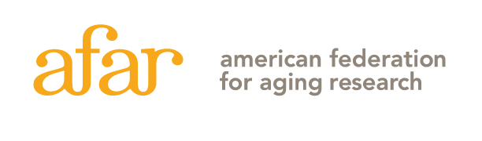
2024 The Sagol Network GerOmic Award for Junior Faculty
Letter of Intent Instruction Sheet - Do not include with your Letter of Intent!

Please carefully read the application guidelines on the AFAR website before completing this LOI. Frequently asked questions can be found here, and things to consider when applying can be found here.

INSTRUCTIONS: The Letter of Intent must be submitted here no later than December 18, 2023, at 5:00 p.m., EST, as a single PDF file application, not to exceed 5 MB. No late submissions will be accepted. The application file should be named as follows: last name, first name; for example, “Smith, Jane.pdf”.

Letter of Intent
Letters of intent will be evaluated on the relevance and significance of the proposed research to the mechanisms of aging and qualifications of the applicant as outlined in the Sagol Award Guidelines.

Please submit the LOI in the order as described below. Insert page number and applicant's name at the top of each page and use a font that is not smaller than 11 pt. with at least 1/2 inch margins on all sides. Any figures and essential references must be included on page 2.

A complete Letter of Intent (no more than 7 pages total) includes:
Page 1: Title Page with abstract (include in space provided)
Page 2: Project Description, A-D must be addressed, following the format below:
- Significance of this research to the field of aging and ger-omics in particular
- Brief description of hypothesis. Include an explanation of the model system(s) to be used – for animal models specify which animal(s), age groups, numbers for each age group and sex. If using a cell line indicate from which organism it is derived.
- List of Specific Aims
- Any figures and essential references (optional)
Pages 3-7: NIH-style biosketch for the applicant (up to 5 pages total) – applicants must be independent investigators with independent research space and must be no more than 10 years beyond start of postdoctoral research training as of July 1, 2024. Be sure to include past and current funding with dollar amounts.

Applicants must have a form completed by the Dean or Department Chair, to be submitted separately by the December 18 deadline to afarapplication@afar.org. Download the form here: https://www.afar.org/imported/docs/AFAR_Institutional_Commitment_Form.docx

The Letters of Intent will be reviewed by a committee. Applicants will be notified by mid-March, and a subset of applicants will be invited to submit a full application by late April.

THIS IS THE INSTRUCTION SHEET! DO NOT INCLUDE IT WITH YOUR LETTER OF INTENT. PLEASE FOLLOW THE INSTRUCTIONS CAREFULLY. LOIs THAT DO NOT FOLLOW THE REQUIRED FORMAT (FOR EXAMPLE, EXCEEDING PAGE LIMIT) WILL BE ADMINISTRATIVELY ELIMINATED. Contact grants@afar.org should you have any questions.
2024 The Sagol Network GerOmic Award for Junior Faculty
Letter of Intent
[Title Page: should be the first page of your application]

ONLY ONE LETTER OF INTENT PER INDIVIDUAL MAY BE SUBMITTED EACH YEAR.
Applicant Information  First Name: Last Name:  Degree(s):  Academic Title:  Institution:  Department:  Mailing Address:  City: State: Zip Code:  Phone: E-mail: | Project Title:
Start date of first Postdoctoral Fellowship (Month/Day/Year):

ABSTRACT: Provide a summary of your research proposal. Do not exceed space provided.
Keywords:

