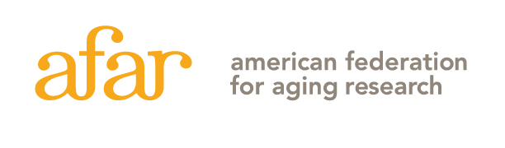

AMERICAN FEDERATION FOR AGING RESEARCH
55 West 39th Street, 16th floor, New York, NY 10018 (212) 703-9977

McKnight Brain Research Foundation Innovator Awards in Cognitive Aging and Memory Loss

Institutional Commitment Form

Candidates for the McKnight Brain Research Foundation Innovator Awards in Cognitive Aging and Memory Loss must be independent investigators with independent research space. To complete the application, this form must be completed by the Dean or the Department Chair. The form is NOT to be included in the application, but must be submitted directly to AFAR by the person completing the form (NOT the applicant), to afarapplication@afar.org as a Word or PDF file.

Name, title, and address of official completing this form:

E-mail:
Phone:

Signature of Official: __________________________________________________

First and Last name of Applicant:_________________________________________

1. Does the candidate have independent investigator status at his/her institution?

YES NO

2. Has the candidate’s institution provided space and equipment specifically dedicated to his/her research program?

YES
Please Describe:

NO
Please describe whose resources the candidate will use to execute the proposed project:

3. Did the candidate receive intramural start-up funds when offered his/her current position? (AFAR does not consider extramural funds from an outside organization/institution as ‘start-up funds’.)

YES
Please provide $ amount and details of start-up funds:

NO

4. Does the candidate have designated administrative support (e.g. someone who helps with editing and submitting grants, tracks budgets, etc.)

YES NO

5. What was the start date of the candidate’s current position?

Month/Day/Year:

6. Does your institution offer tenure:

YES NO

- If yes, is the candidate’s current position a tenure track position?

YES NO

- If your institution does not offer tenure, please provide evidence of long-term institutional support

7. Will your institution be willing to commit 50% in cash or in-kind matching funds determined to be equivalent, if an award is made?

YES NO

8. Does the candidate have teaching and/or clinical responsibilities in the current position?

YES NO

If yes, indicate percentage of time:

